* **24. Loops - while Loop**
* Loops
* Loops are the way of repeating lines of codes until loop condition is met.
* Loops in java:
* While loop.
* Do-while loop.
* For Loop.
* Enhanced For Loop.
* While Loop
* While loop repeats a block of code until the condition is true.
* As soon as the condition becomes false, it comes out of the loop.
* Syntax:

While (condition){

//block of codes

}

//where condition is a Boolean expression

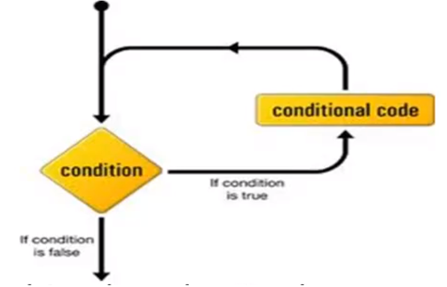

* While(Boolean Condition Only); you cannot write while(int i<=10).
* We can write like this.

**public** **static** **void** main(String[] args) {

**int** i=1;

**while**(i<=10) {

System.***out***.println(i);

}

}

* We can write like this also:

**public** **class** WhileLoop {

**public** **static** **void** main(String[] args) {

**int** i = 1;

**while** (i <= 10)

System.***out***.println(i);

i++;

}

}

* In the above case it will keep printing once. Ie scope of the while loop is till the next semi-colon.
* Now for below codes what will be the output?

**public** **class** WhileLoop {

**public** **static** **void** main(String[] args) {

**int** i = 1;

**while** (i <= 10);

System.***out***.println(i);

i++;

}

}

* The above code wont print anything; but will be an infinite loop.
* Loops are not statements > They are not terminated but exists.
* Entry Criteria: loop condition must be true.
* Exit Criteria: Loop condition must be false.

******